IBM-SMARTZ BRIDZ 5 DAY FDP PROGRAM

VENUE: R610

TIME: 9:30-5:20PM

DURATION: 23-08-2023 TO 27-08-2023

TRAINER NAME: MAHENDER REDDY

STEP BY STEP INSTALLATION

INSTALL VISUAL STUDIO CODE

INSTALL PYTHON 3.14 FROM MICROSOFT STORE

SET ENVIRONMENT VARIABLE

OR

TO KNOW PATH TYPE

CMD: PYTHON --VERSION

OR

>>> import os  
>>> import sys  
>>> os.path.dirname(sys.executable)

INSTALL FLASK

THEN START WRITING CODE IN VSC

DEMO.PY

|  |
| --- |
| from flask import Flask  app = Flask(__name__)  @app.route("/")  def hi():  return "Welcome all"  @app.route("/type/<desg>")  def desg(desg):  return " Welcome all hi " +desg+"to class"  if __name__ == "__main__":  app.run(debug=True) |

DEMO2.PY

|  |
| --- |
| from flask import Flask, url_for,redirect  app = Flask(__name__)  @app.route("/faculty")  def faculty():  return "Welcome all faculties to FDP on Cloud"  @app.route("/type/<desg>")  def desg(desg):  return " Welcome all hi " +desg+ "to class"  @app.route("/to/<person>")  def to(person):  if person == "faculty":  return redirect(url_for("faculty"))  else:  return redirect(url_for("desg", desg = person))  if __name__ == "__main__":  app.run(debug=True) |

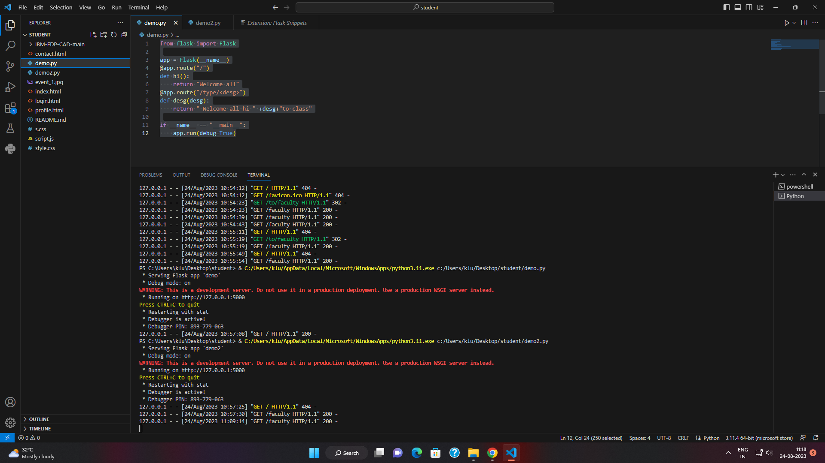

RUN THE CODE

COPY <http://127.0.0.1:5000/faculty> this in the browser

OUTPUT

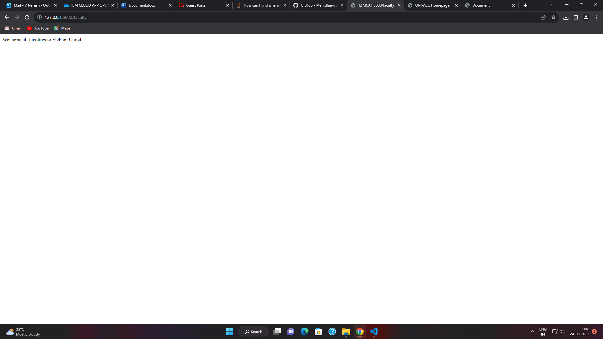

https://www.javatpoint.com/flask-http-methods

|  |
| --- |
|  |

2)

Folder Structure

1)Static(folder)

a) …..css .css

b)….javafile . js

c)…. Image . jpeg

d)---scripts

2)Template(folder)

a .html

3).py(file)

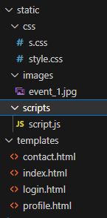

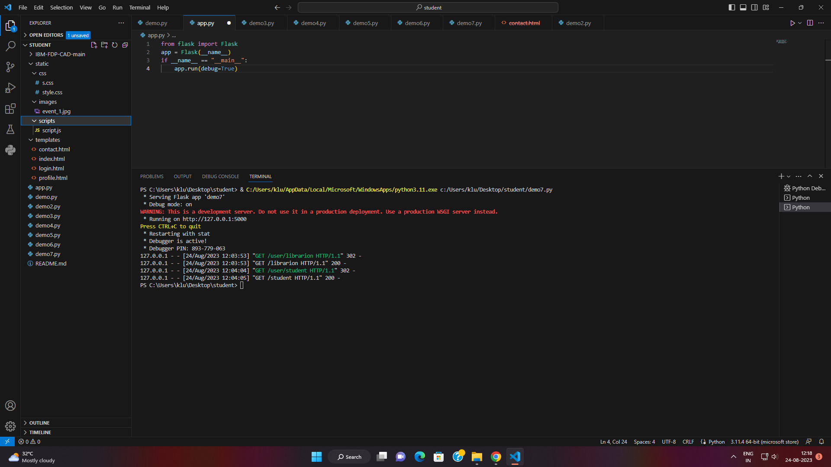

App.py

|  |
| --- |
| from flask import Flask, render_template  app = Flask(__name__)  @app.route("/")  def index():  return render_template("index.html")  @app.route("/contact")  def contact():  return render_template("contact.html")  @app.route("/login")  def login():  return render_template("login.html")  if __name__ == "__main__":  app.run(debug=True) |

Index.html

|  |
| --- |
| <!DOCTYPE html>  <html lang="en">  <head>  <meta charset="UTF-8" />  <meta name="viewport" content="width=device-width, initial-scale=1.0" />  <title>UNI-ACC Homepage</title>  <link rel="stylesheet" href="/static/css/s.css" />  <link  href="https://fonts.googleapis.com/css2?family=Space+Mono&display=swap"  rel="stylesheet"  />  </head>  <body>  <nav class="navbar">  <img src="/static/images/logo.jpeg" alt="logo" width="300" height="100" />  <ul class="nav-links">  <li><a href="/">Home</a></li>  <li><a href="/contact">Contact</a></li>  <li class="dropdown">  <div class="dropbtn" id="loginBtn">Login</div>  <div class="dropdown-content" id="myDropdown">  <a href="/login">Student</a>  <a href="/login">Faculty</a>  <a href="/login">Admin</a>  </div>  </li>  </ul>  </nav>  <section class="hero">  <h1>KLU</h1>  <p>  A digital initiative by the institute facilitating Faculty, Students,  Parents, and Alumni to access and process Academics, Research,  Supporting services at one common platform.  </p>  </section>  <script src="/static/scripts/script.js"></script>  </body>  </html> |

Contact.html

|  |
| --- |
| <!DOCTYPE html>  <html lang="en">  <head>  <meta charset="UTF-8" />  <meta name="viewport" content="width=device-width, initial-scale=1.0" />  <title>Document</title>  <link rel="stylesheet" href="/static/css/s.css" />  </head>  <body>  <nav class="navbar">  <img src="/static/images/logo.jpeg" alt="Logo" width="300" height="100" />  <ul class="nav-links">  <li><a href="/">Home</a></li>  <li><a href="/contact">Contact</a></li>  <li class="dropdown">  <div class="dropbtn" id="loginBtn">Login</div>  <div class="dropdown-content" id="myDropdown">  <a href="login.html">Student</a>  <a href="login.html">Faculty</a>  <a href="login.html">Admin</a>  </div>  </li>  </ul>  </nav>  <section class="contact-section">  <h2>Contact Us</h2>  <form action="#" method="post">  <label for="name">Name:</label>  <input type="text" id="name" name="name" required />  <label for="email">Email:</label>  <input type="email" id="email" name="email" required />  <label for="message">Message:</label>  <textarea id="message" name="message" rows="4" required></textarea>  <input type="submit" value="Send" />  </form>  </section>  <script src="/static/scripts/script.js"></script>  </body>  </html> |

Login.html

|  |
| --- |
| <!DOCTYPE html>  <html lang="en">  <head>  <meta charset="UTF-8" />  <meta name="viewport" content="width=device-width, initial-scale=1.0" />  <title>UNI-ACC Login Page</title>  <link rel="stylesheet" href="/static/css/s.css" />  <link  href="https://fonts.googleapis.com/css2?family=Space+Mono&display=swap"  rel="stylesheet"  />  </head>  <body>  <nav class="navbar">  <img src="/static/images/logo.jpeg" alt="Logo" width="300" height="100" />  <ul class="nav-links">  <li><a href="/">Home</a></li>  <li><a href="/login">Login</a></li>  <li class="dropdown">  <div class="dropbtn" id="loginBtn">Login</div>  <div class="dropdown-content" id="myDropdown">  <a href="login">Student</a>  <a href="login">Faculty</a>  <a href="login">Admin</a>  </div>  </li>  </ul>  </nav>  <!-- Login Section -->  <section class="login-section hero">  <h2>Login</h2>  <form action="#" method="post">  <label for="username">Username:</label>  <input type="text" id="username" name="username" required />  <label for="password">Password:</label>  <input type="password" id="password" name="password" required />  <input type="submit" value="Login" class="dropbtn" />  </form>  </section>  <script src="/static/scripts/script.js"></script>  </body>  </html> |

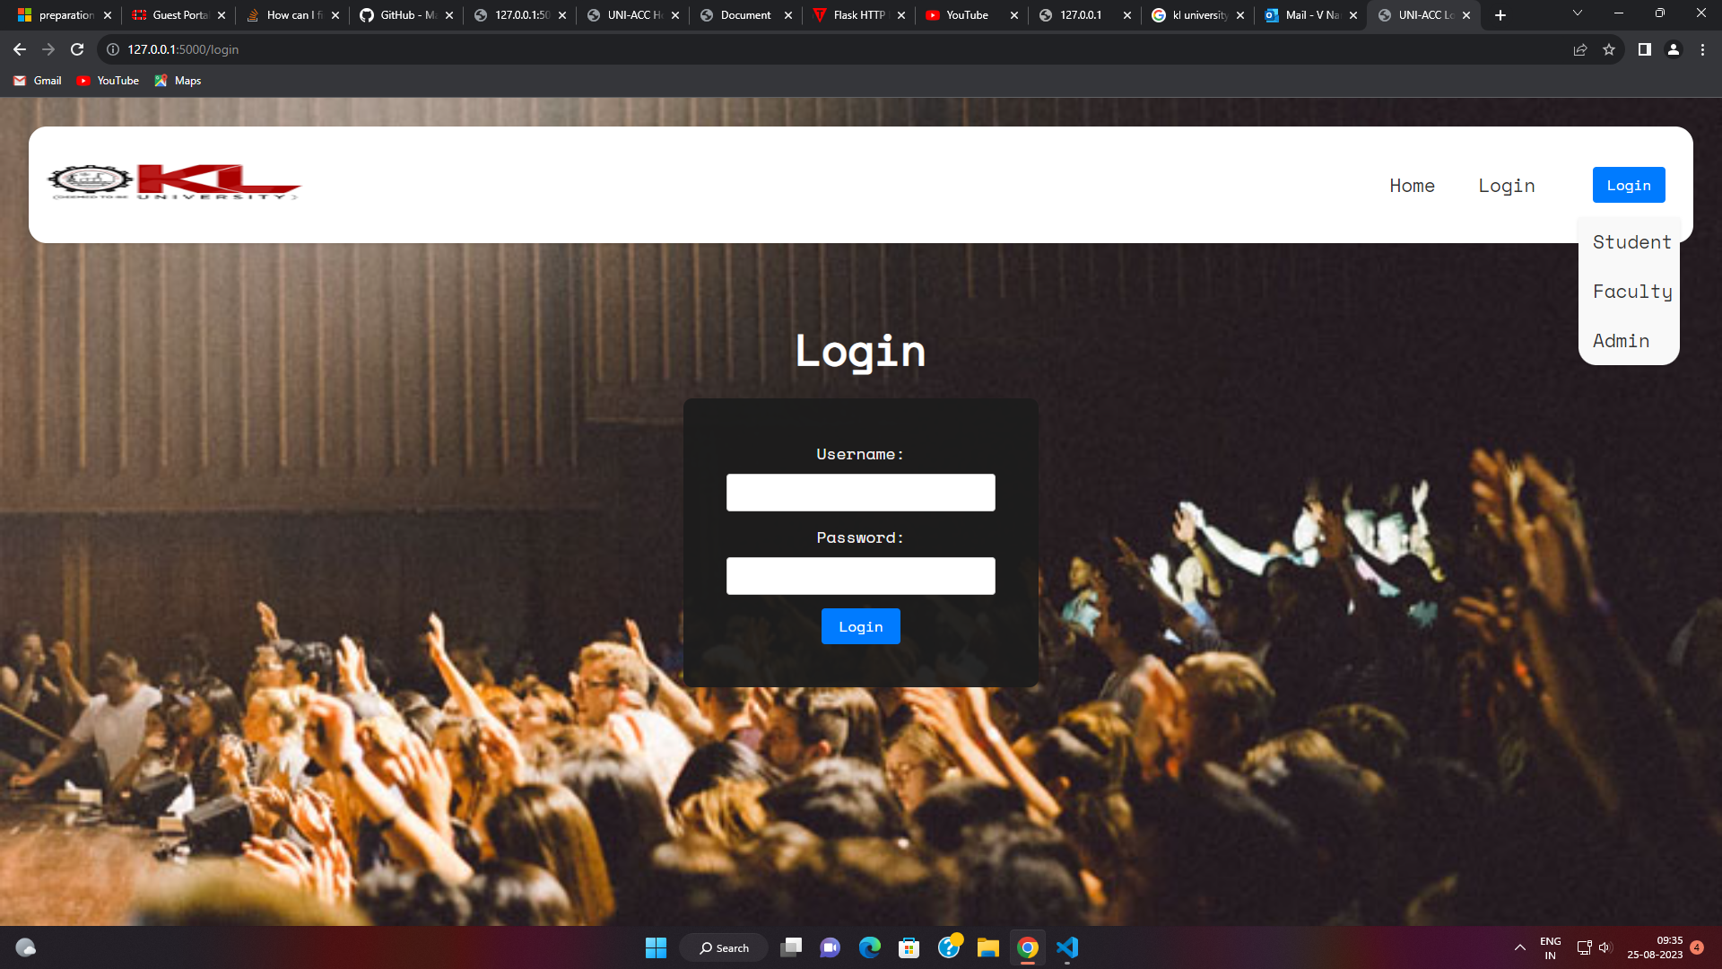

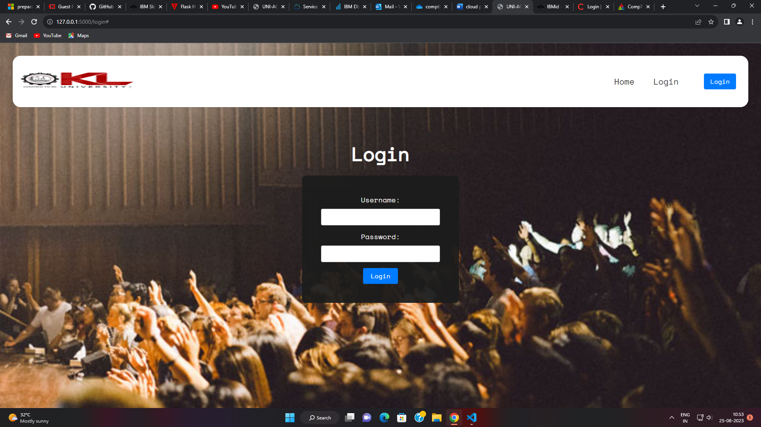

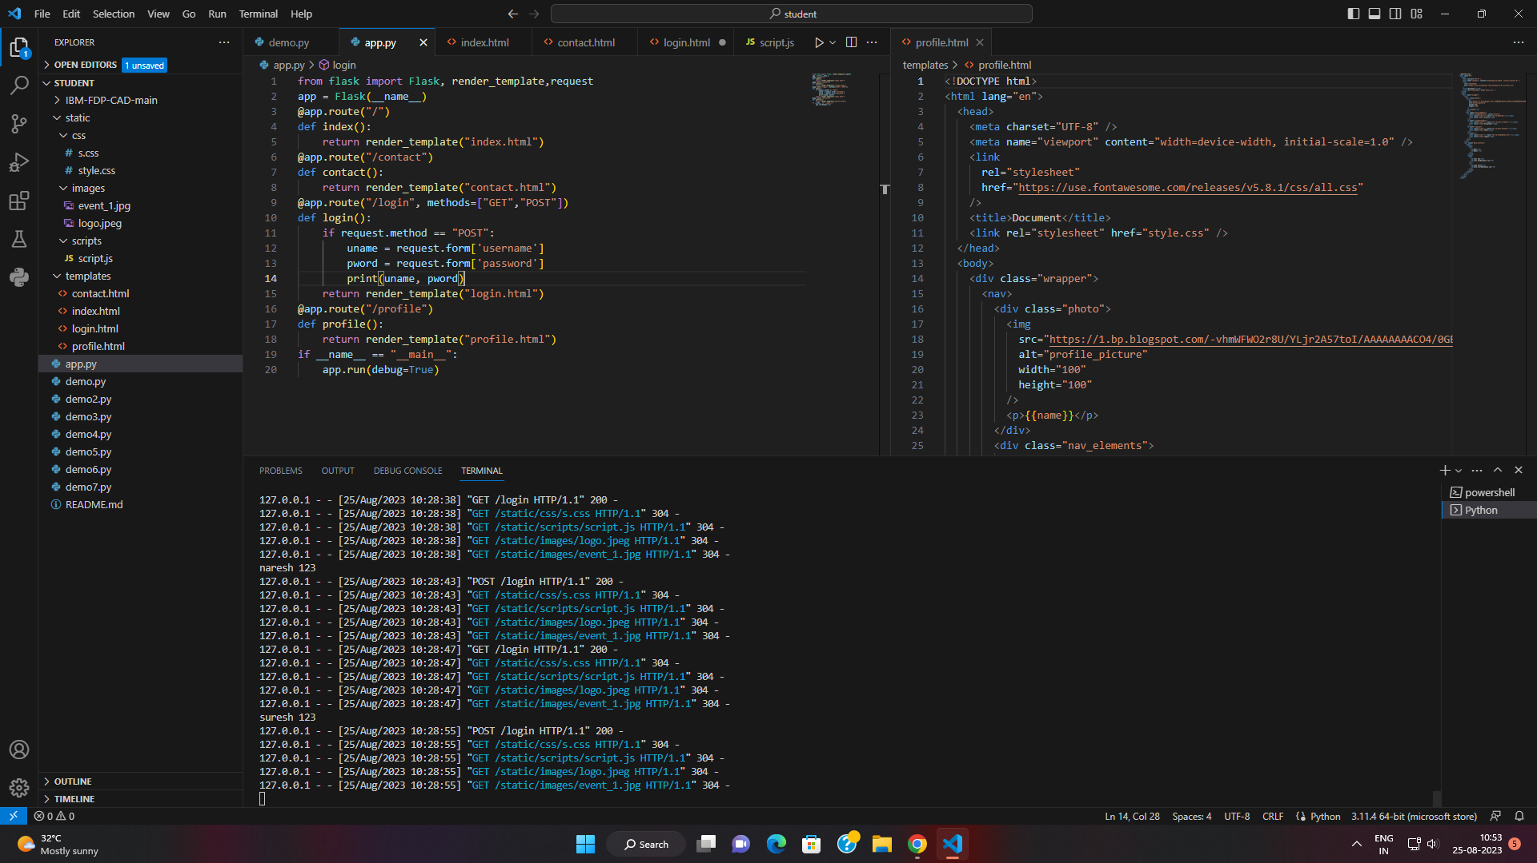

Day 3:

IBM CLOUD CONNECTING DB2:

LOGIN INTO

IBM.CLOUD.COM

SELECT DB2 FROM RESOURCE LIST

GOTO DB2

GOTO DATA

GOTO TABLE

NEW TABLE

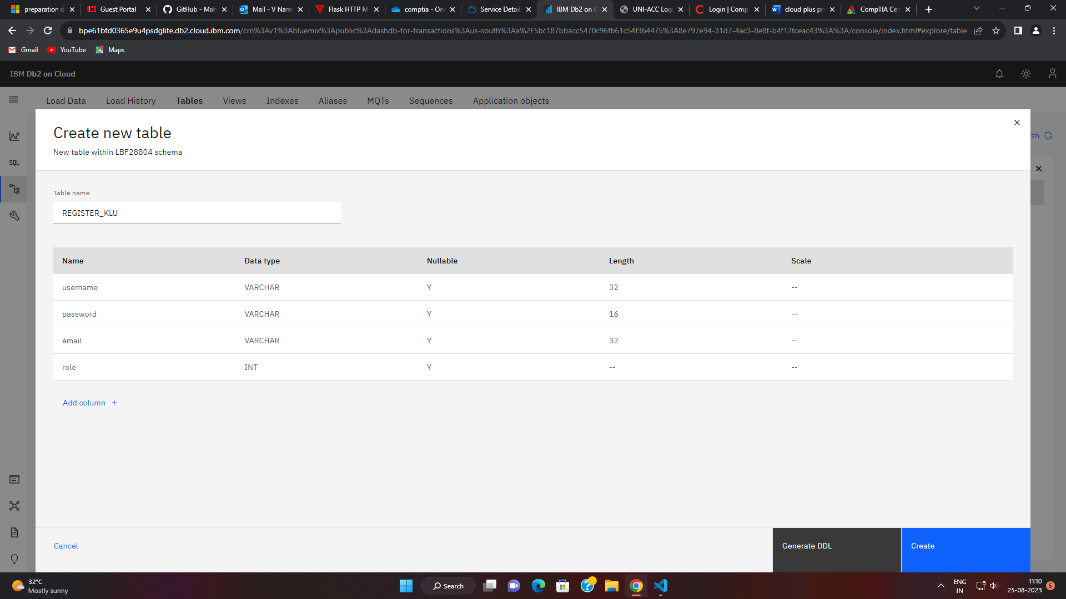

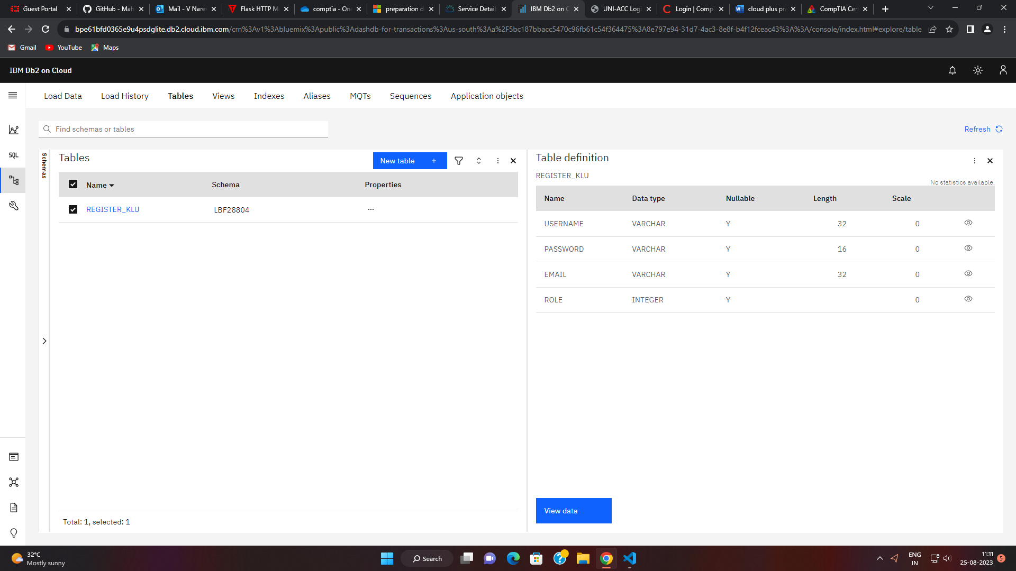

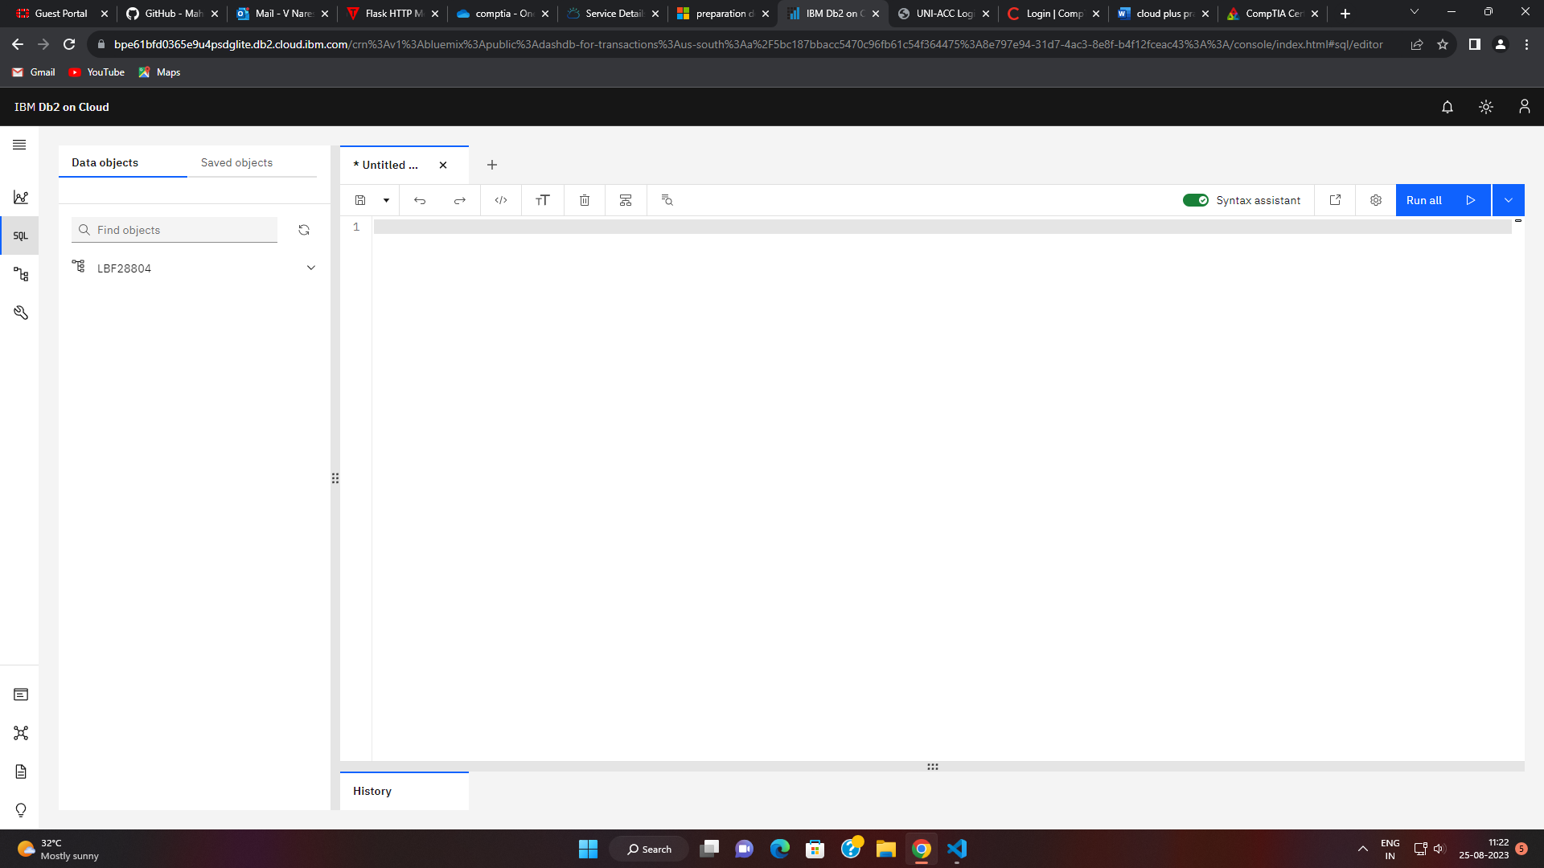

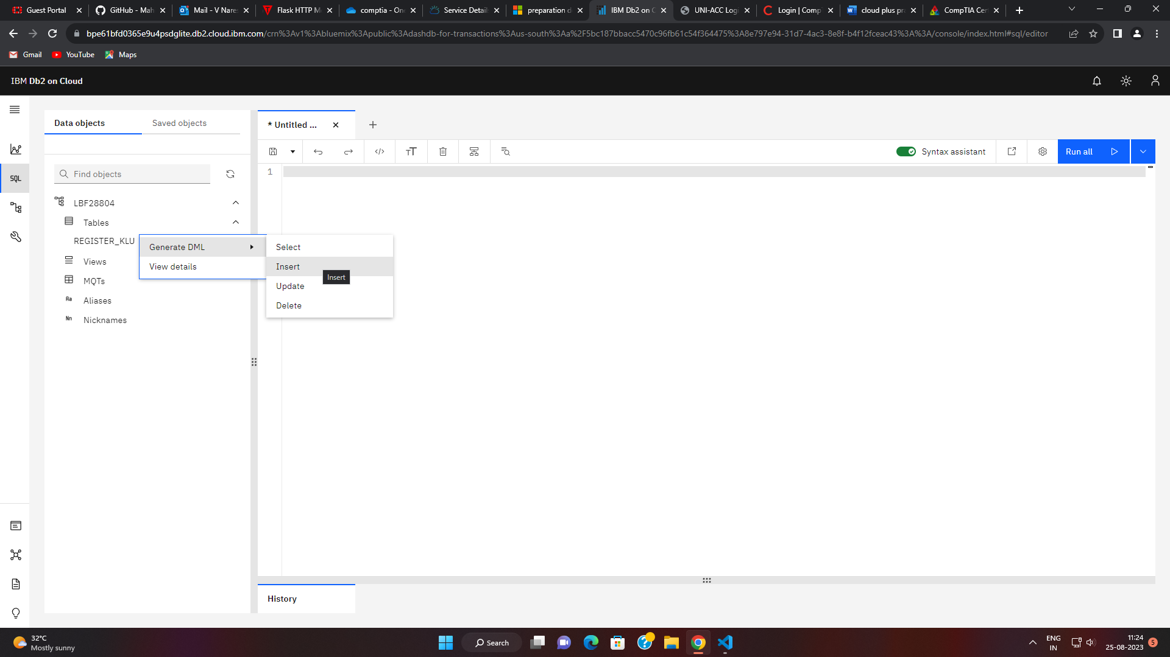

1. Admin
2. Student
3. Faculty

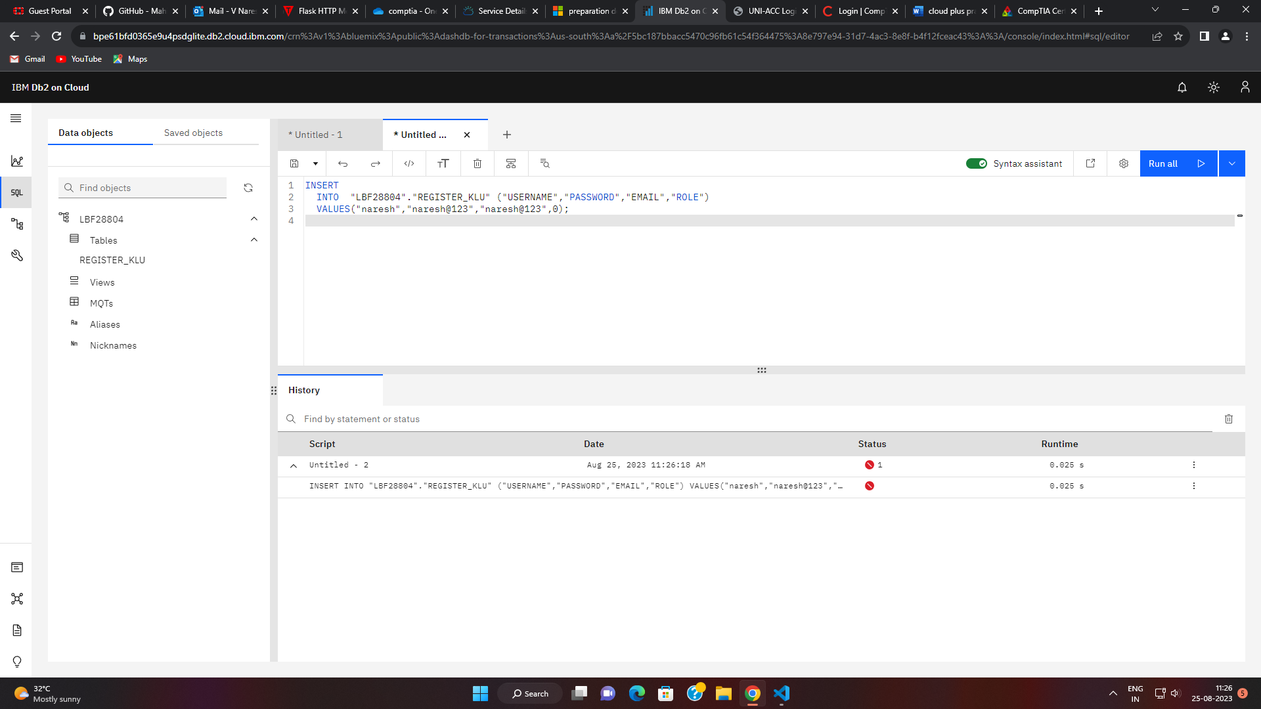

Run all

Give it in single quotation

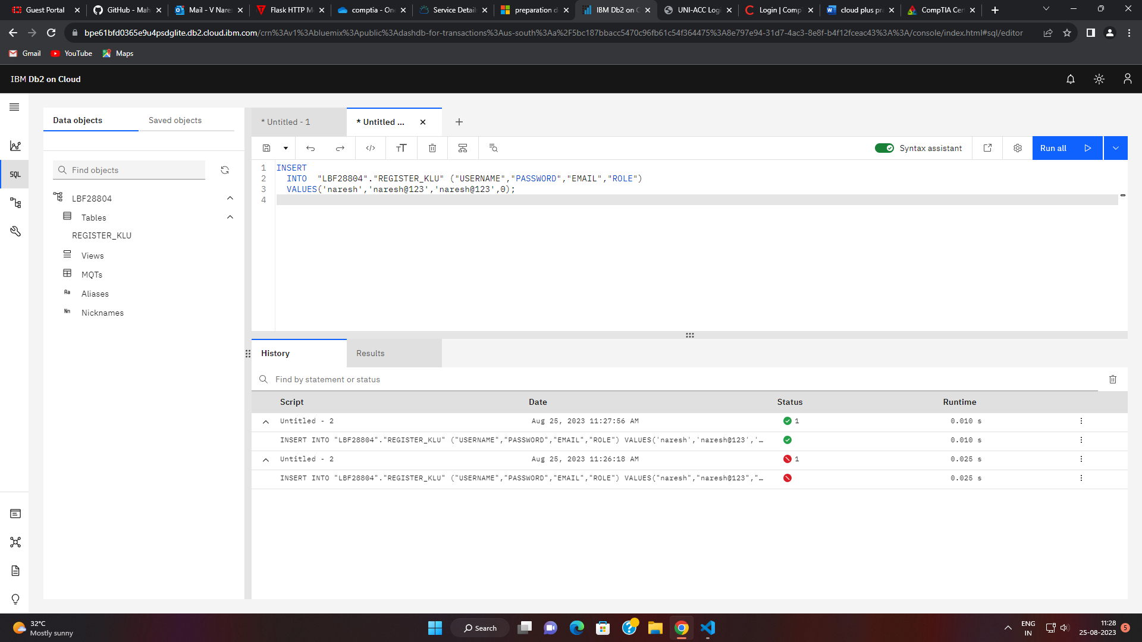

After view data

In command prompt

Type this command for db download

pip install ibm-db

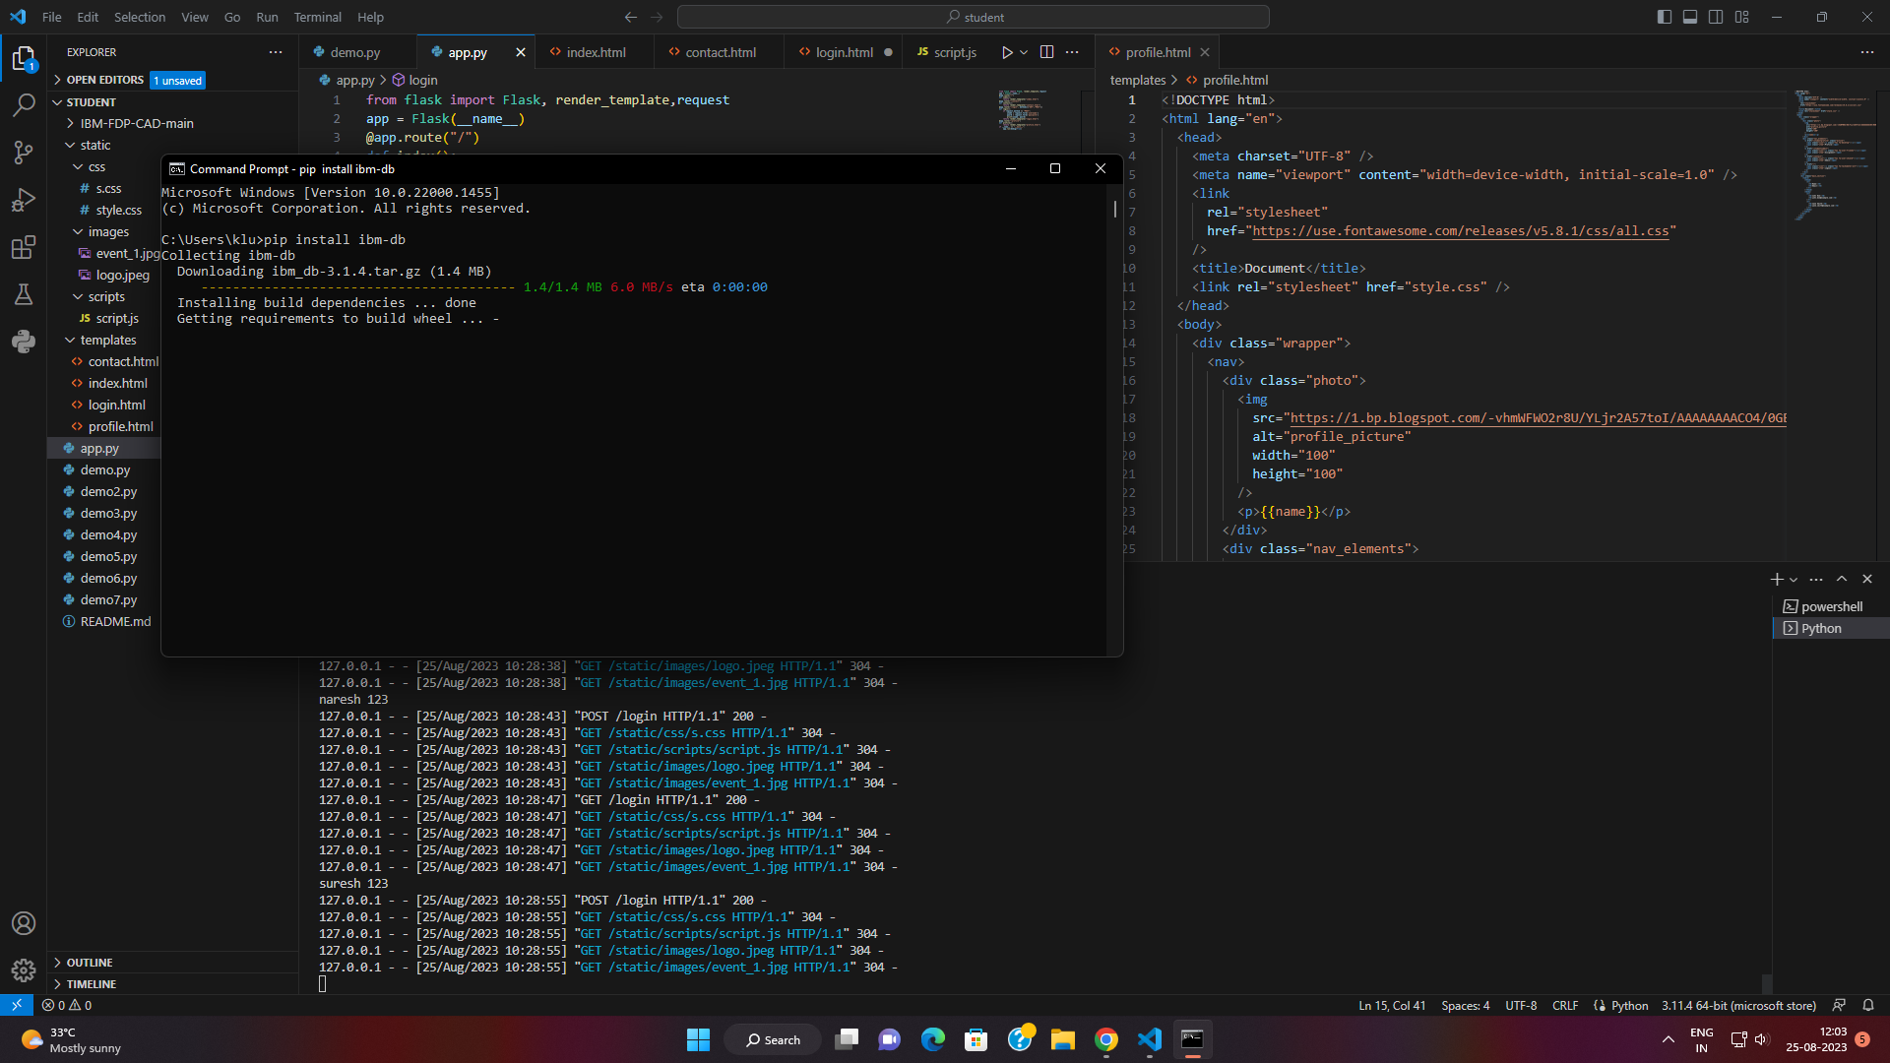

Goto git

<https://github.com/Mahidhar-SB/IBM-FDP-CAD>

https://github.com/ibmdb/python-ibmdb/wiki/APIs#ibm_dbconnect

CREATE SERVICE CREDENTIALS IN IBM CLOUD

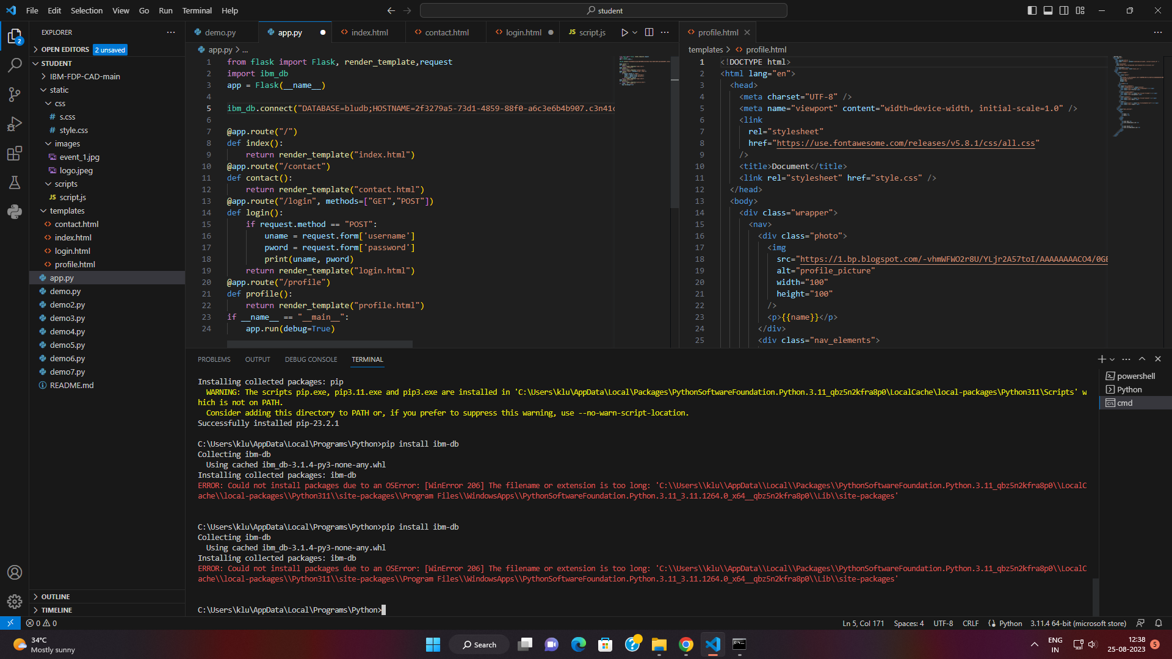

If any OSERROR

Use this [[SOLVED] The File Name Too Long Error (100% Working)](https://www.youtube.com/watch?v=obJmcid_erI)

Goto Registry

Filesystem

Change 0 to 1

Refer this link:

<https://www.youtube.com/watch?v=obJmcid_erI>

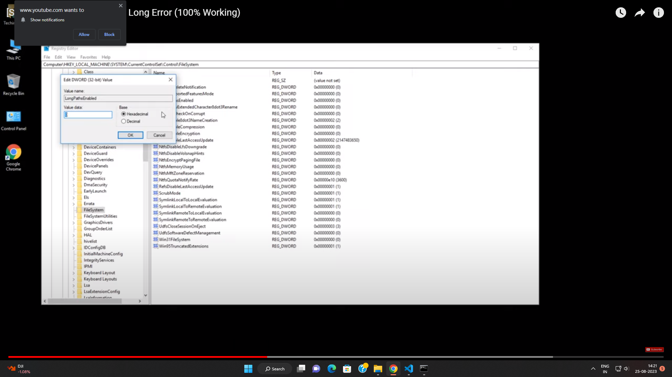

ADD ALL DETAILS

import ibm_db

app = Flask(__name__)

ibm_db.connect("DATABASE=bludb;HOSTNAME=2f3279a5-73d1-4859-88f0-a6c3e6b4b907.c3n41cmd0nqnrk39u98g.databases.appdomain.cloud;PORT=30756;UID=lbf28804;PWD=E4Q0HWOyKeWkBlh1")

GOTO IBMCLOUD

ADMINISTRATION

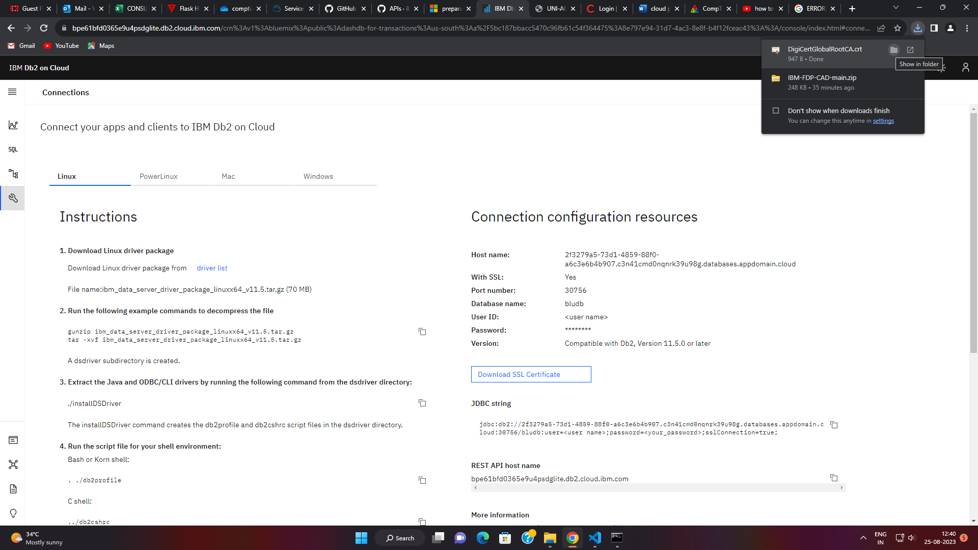

DOWNLOAD SSL CERTIFICATE

KEEP IT IN PROJECT FOLDER I.E STUDENT FOR US EXAMPLE

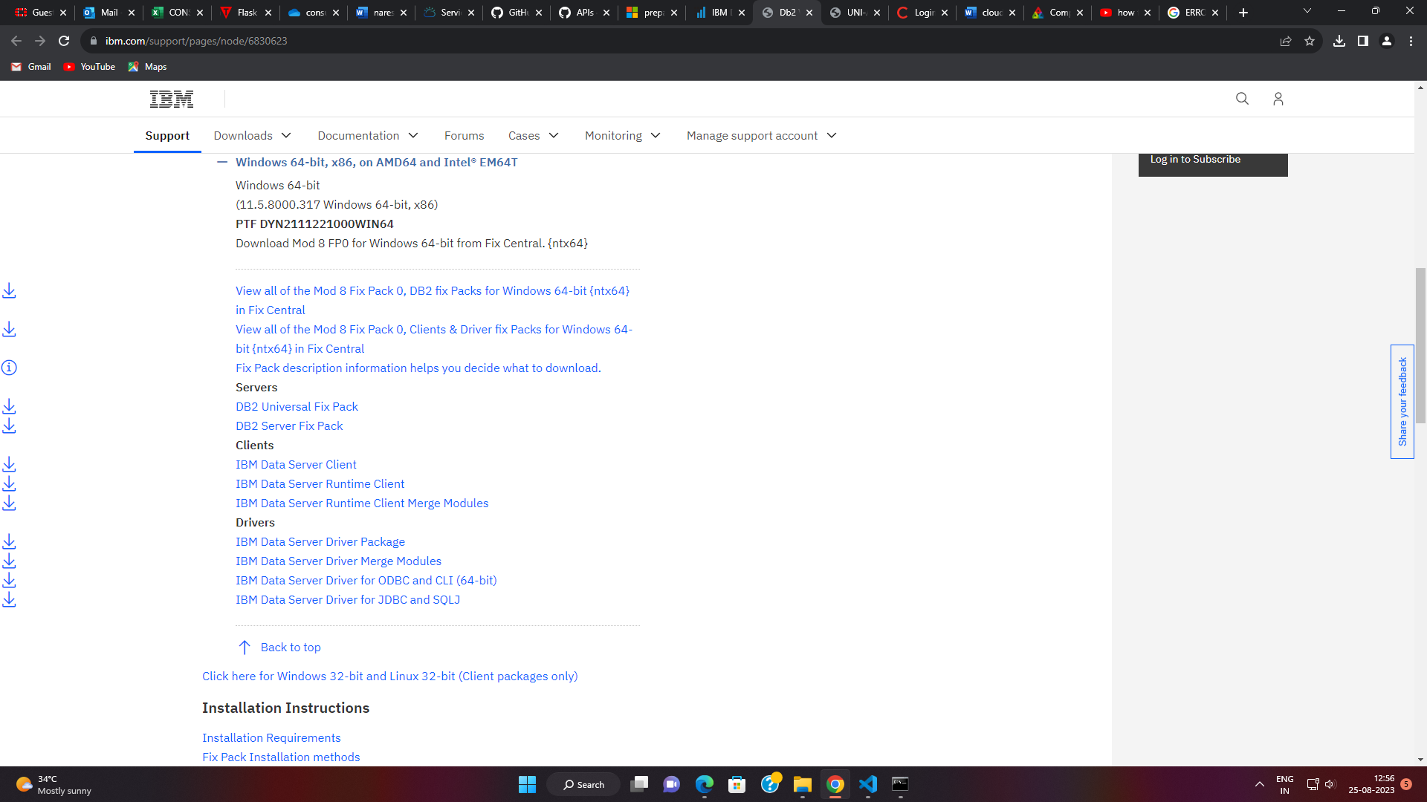

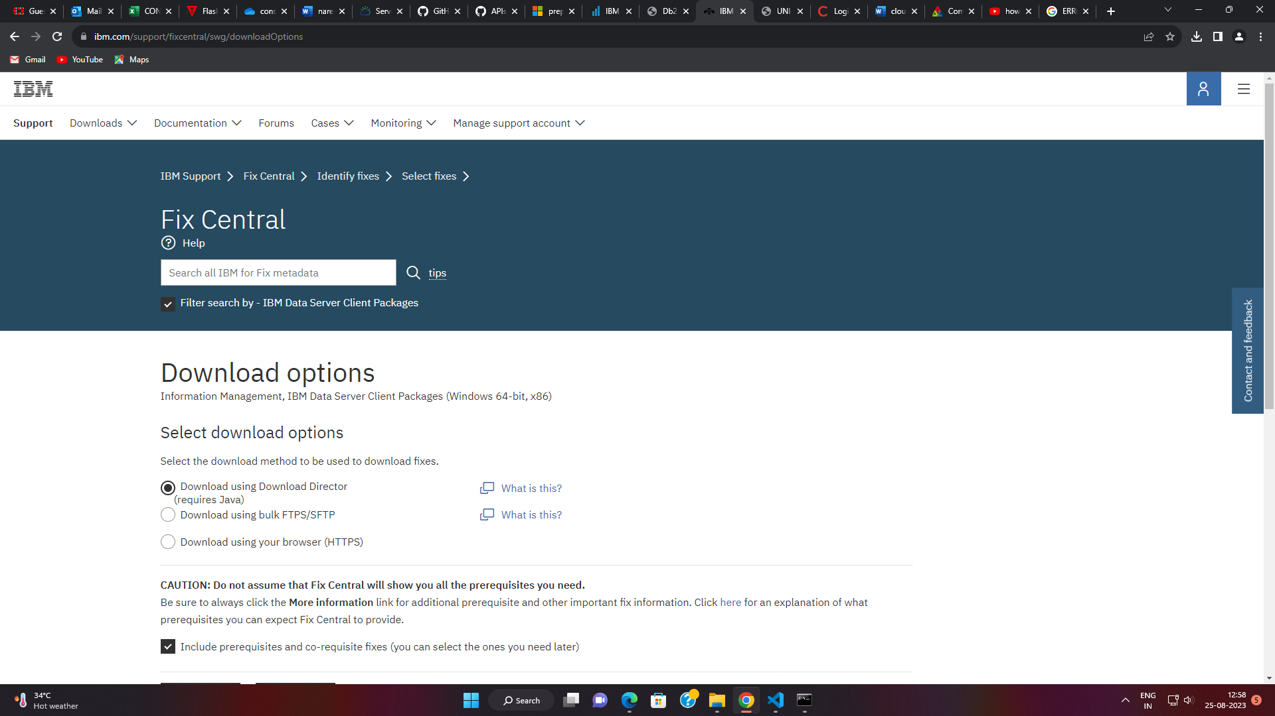

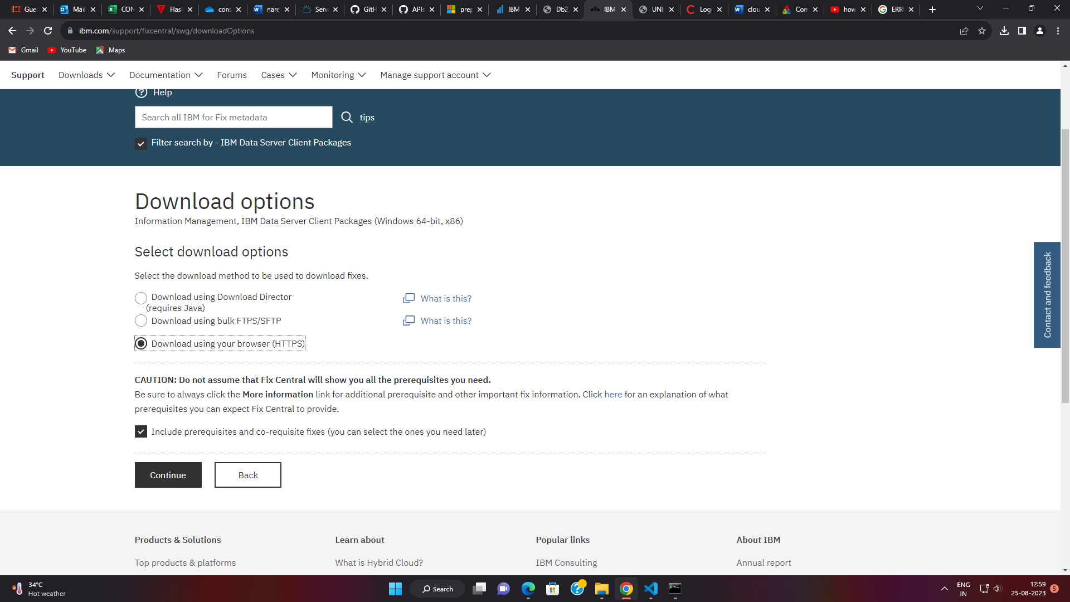

Click on continue

2 exe file download

(english based only) 72mb downloaded

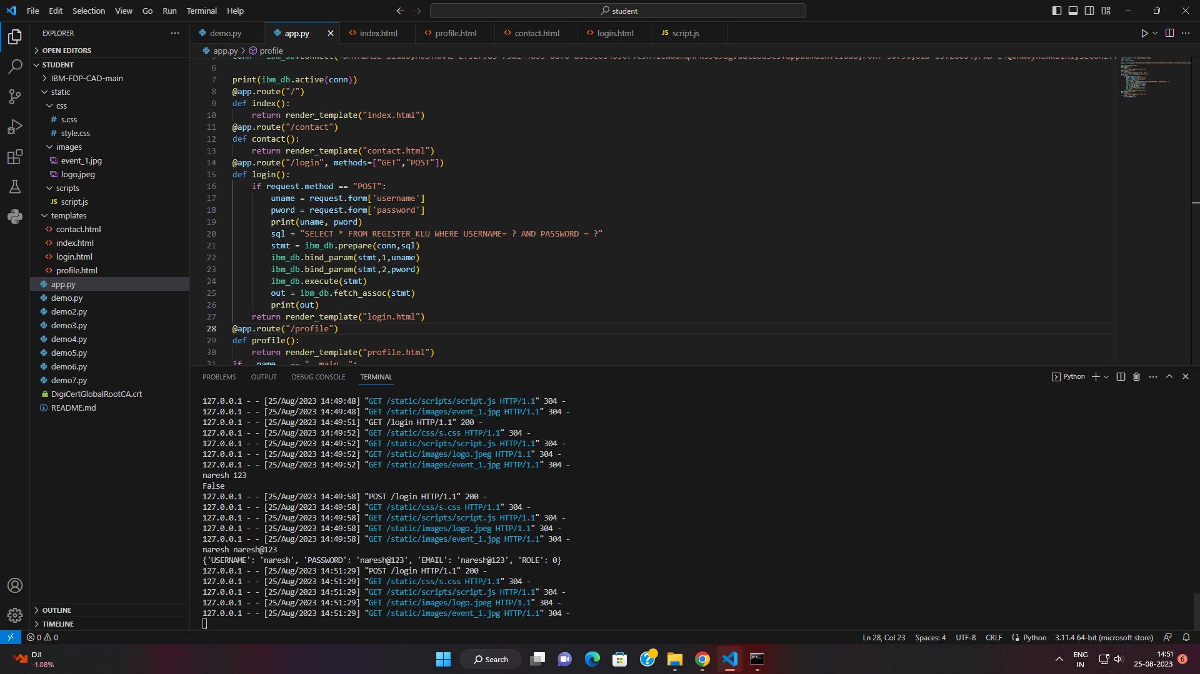

After login :

If correct username and password

Its fetching

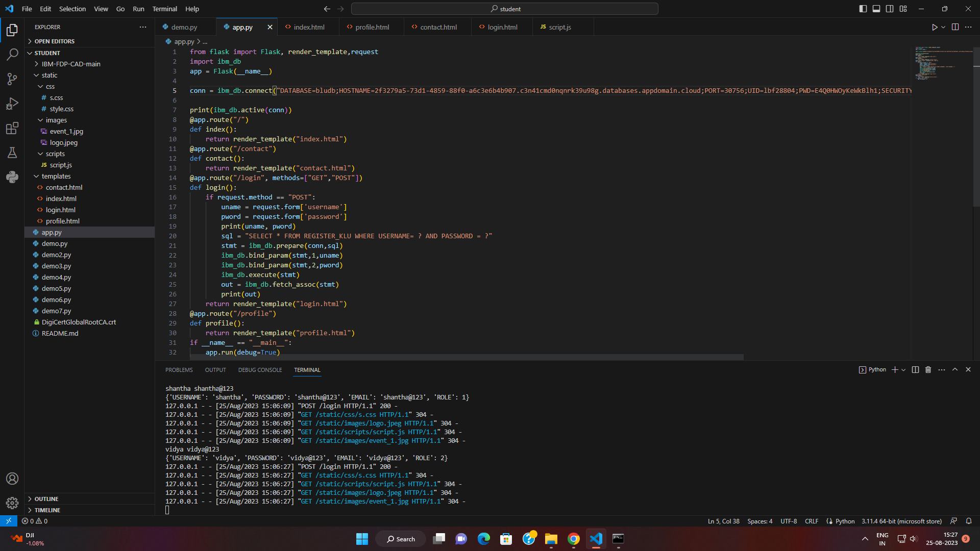

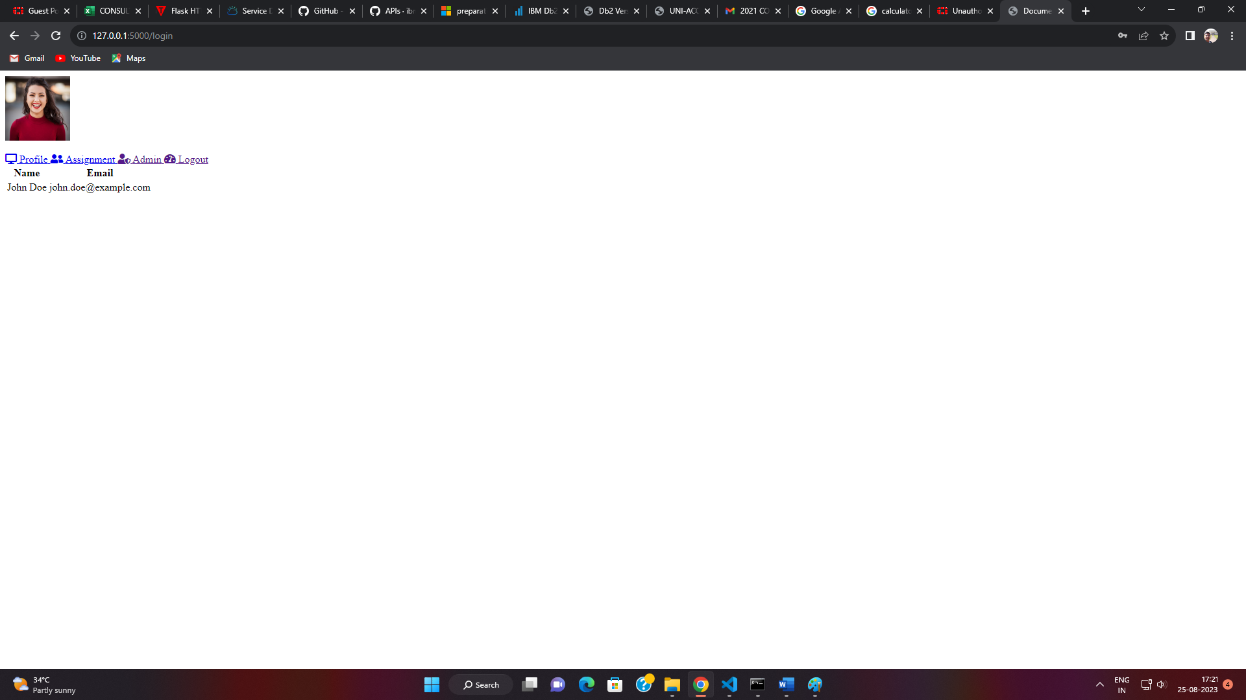

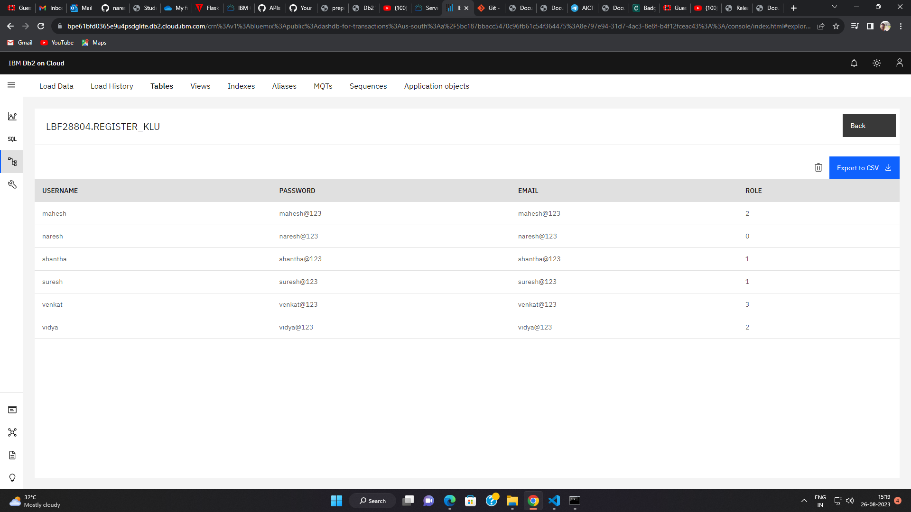

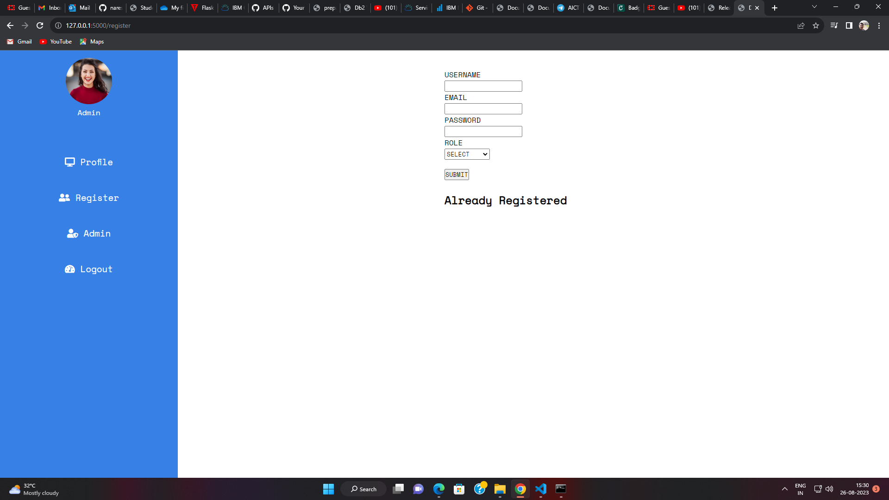

Learning about git

Containarization is a technology (technique) and

Docker Is a tool , virtualization.

Provides the ability to package and run application in a loosely isolated environment called a container.

Wsl - windows subsystem for linux

Powershell

Wsl—install

Wsl –update

It uses ubuntu os

Installation

COMMUNITY EDITION -FREE

ENTERPRISE EDITION

https://www.docker.com/get-started

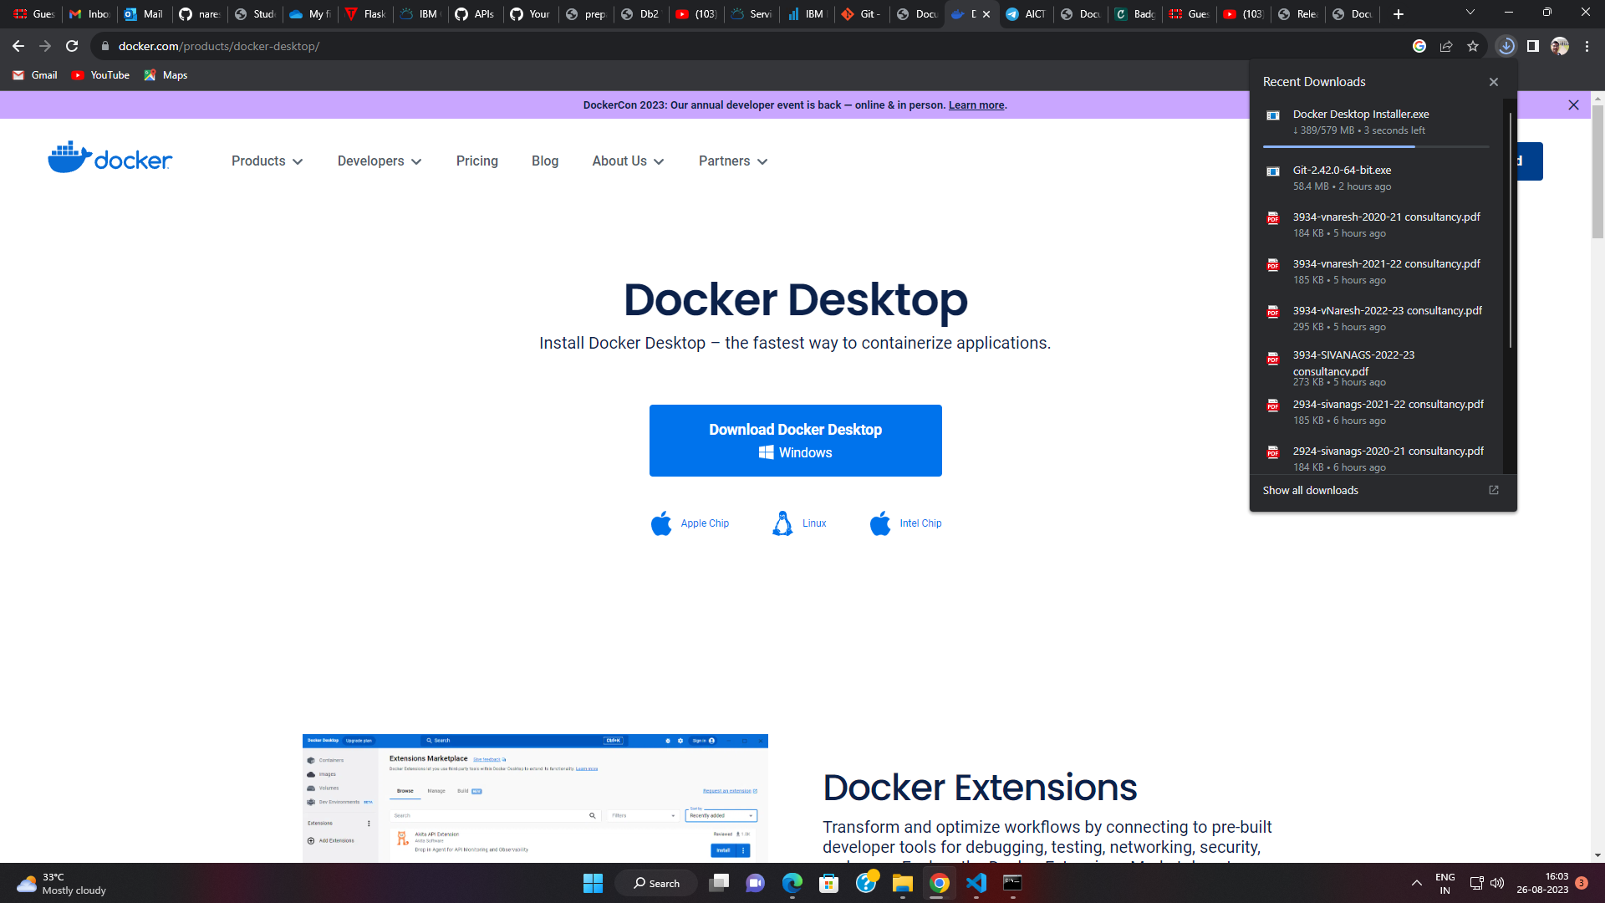

Install

